Lin Tun

CSC621-01

Team Earth

Analysis of Severity of COVID-19

**Sample Test of Positive Covid Test with the analysis of part that had COVID-19**

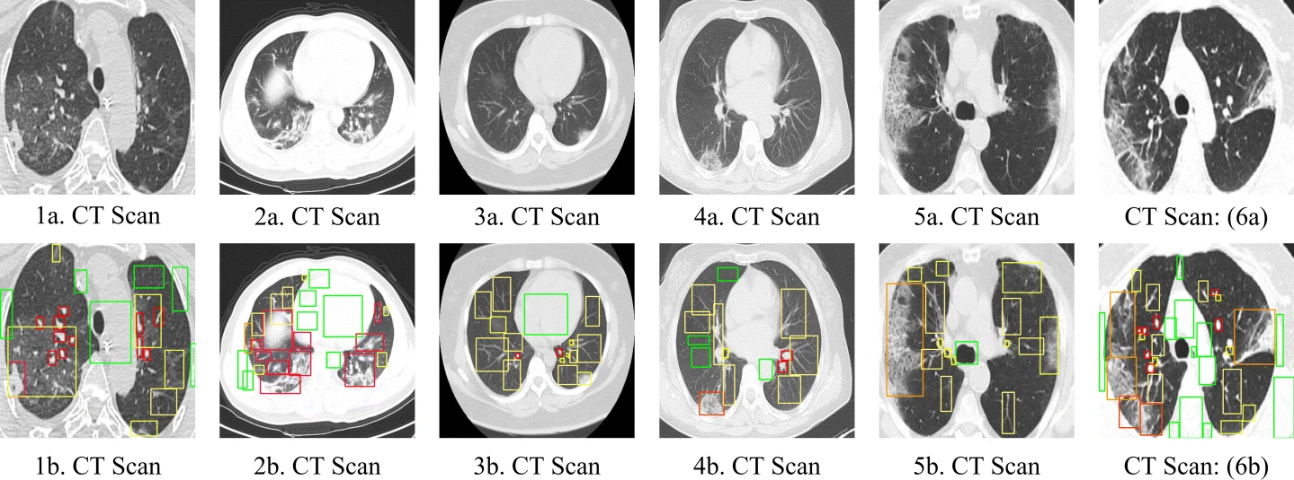

* The images show labeled COVID-19 characteristics in descending severity order, from yellow to red colored bounding boxes.
* The green bounding boxes emphasize negative samples or background categories for the model's hard negative mining.

**Example of the Covid Positive and Negative according to the research article**

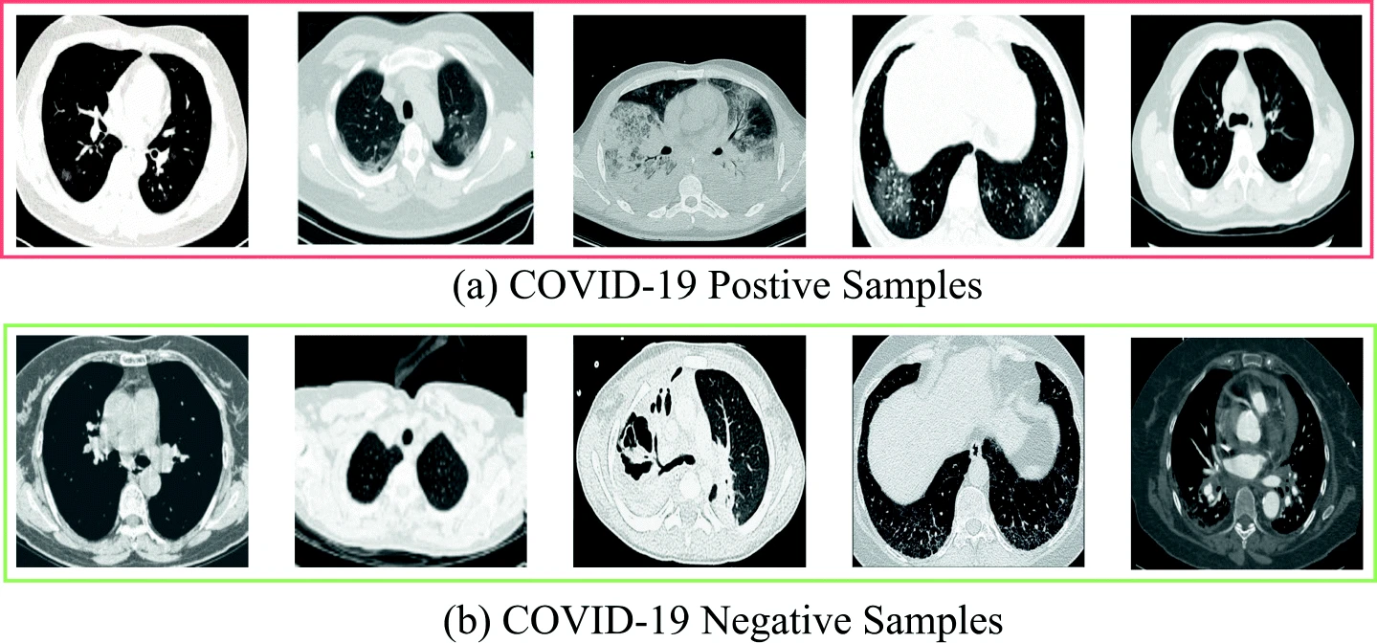

Reference from [Quantifying prognosis severity of COVID-19 patients from deep learning based analysis of CT chest images](https://link.springer.com/article/10.1007/s11042-022-12214-6).

Quantification Results

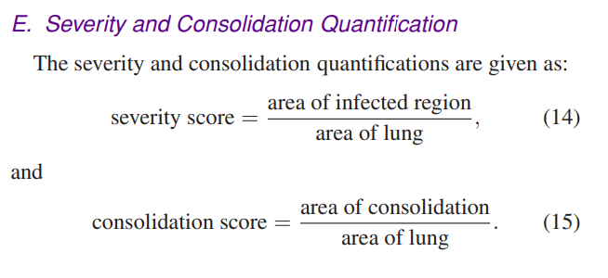

**Our Database of Positive Covid Patients**

|  |  |
| --- | --- |
| 2.000000-ROUTINE CHEST NON-CON-50599 | 2.000000-ROUTINE CHEST NON-CON-70218 |
| Manual of severity score  Severity score= $\frac{278.86205291748047 cm³}{37097.71881866455 cm³}$ = $0.00752$ Algorithm of severity score  Severity score= $\frac{327.2011413574219 cm³}{37097.71881866455 cm³}$ = $0.00882$ | Manual of severity score  Severity score= $\frac{1279.5641784667969 cm³}{1649.4746017456055 cm³}$ = $0.77574$ Algorithm of severity score  Severity score= $\frac{524.3537521362305 cm³}{1649.4746017456055 cm³}$ = $0.31789$ |
| Jaccard Index: 0.42064870518260133 | Jaccard Index: 0.34470577992263585 |

|  |  |
| --- | --- |
| 2.000000-ROUTINE CHEST NON-CON-97100 | 2.000000-ROUTINE CHEST WITH CONTRAST-49240 |
| Manual of severity score  Severity score= $\frac{277.4413146972656 cm³}{4330.8995361328125 cm³}$ = $0.06406$ Algorithm of severity score  Severity score= $\frac{227.7649154663086 cm³}{4330.8995361328125 cm³}$ = $0.06414$ | Manual of severity score  Severity score= $\frac{13.640693664550781 cm³}{5027.218231201172 cm³}$ = $0.00271$ Algorithm of severity score  Severity score= $\frac{30.601181030273438 cm³}{5027.218231201172 cm³}$ = $0.00609$ |
| Jaccard Index: 0.6030444689337103 | Jaccard Index: 0.13849750326007443 |

|  |  |
| --- | --- |
| 3.000000-0.625mm bone alg-30767 | 601.000000-COR 3X3-19359 |
| Manual of severity score  Severity score= $\frac{507.95562744140625 cm³}{2267.6545486450195 cm³}$ = $0.224$ Algorithm of severity score  Severity score= $\frac{323.6978073120117 cm³}{2267.6545486450195 cm³}$ = $0.14275$ | Manual of severity score  Severity score= $\frac{581.5799153745174 cm³}{2312.5352719960215 cm³}$ = $0.25149$ Algorithm of severity score  Severity score= $\frac{357.3633382966518 cm³}{2312.5352719960215 cm³}$ = $0.15453$ |
| Jaccard Index: 0.5372794191561497 | Jaccard Index: 0.5199053111240223 |

|  |
| --- |
| 601.000000-COR 3X3-53956 |
| Manual of severity score  Severity score= $\frac{49.83823755419254 cm³}{5065.439931783557 cm³}$ = $0.00983$ Algorithm of severity score  Severity score= $\frac{7.805810321927071 cm³}{5065.439931783557 cm³}$ = $0.00154$ |
| Jaccard Index: 0.07560746111695356 |

**To analyze the negative COVID-19 patients' lungs, overlay the CT Scan of positive Covid patient**

|  |  |
| --- | --- |
| Example of Covid Positive patient | 1.000000-NA-51699 |

|  |  |
| --- | --- |
| 2.000000-CHEST WITHOUT CONTRAST-71297 | 2.000000-CTA PE-14198 |

|  |  |
| --- | --- |
| 2.000000-NA-07089 | 2.000000-NA-11876 |

**Our Database of Negative Covid Patients**

|  |  |
| --- | --- |
| 1.000000-NA-51699 | 2.000000-CHEST WITHOUT CONTRAST-71297 |

|  |  |
| --- | --- |
| 2.000000-CTA PE-14198 | 2.000000-NA-07089 |

|  |
| --- |
| 2.000000-NA-11876 |